1. **Governance of colonial Hong Kong since the 1967 Riots**

Study Sources A and B.

**SOURCE A**

The following is adapted from the cover of a comic book published in Hong Kong in 1974.

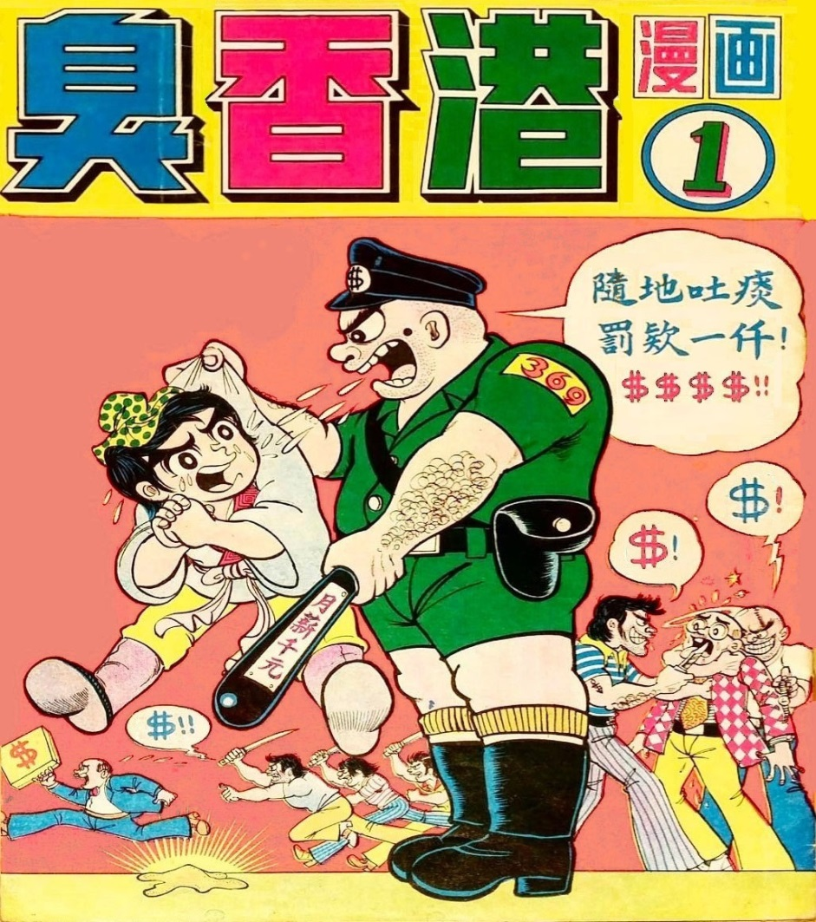

* 臭香港漫画 : Smelly Hong Kong Comics

隨地吐痰，罰欵一仟 : Fine for spitting – $1 000

月薪千元 : Monthly salary – $1 000

Note:

* Normally, the penalty for spitting at the time ranged from HK$15 to HK$100.
* ‘369’ was the number assigned to the policeman.

**SOURCE B**

The following is adapted from a feature about Hong Kong written by a mainland Chinese reporter, published in 1997.

|  |  |  |
| --- | --- | --- |
|  | Generally speaking, the people of Hong Kong do appreciate the work of its police force, which acts in a civilised and friendly manner. A lawyer who came from the mainland to work in Hong Kong told me that he once reported the loss of his identity card to a policeman nearby. Before he arrived at his office, he had already received a call from the same policeman, informing him that his card had been found. Upon picking up his card, the lawyer was so pleased that he offered the policeman 500 dollars as a sign of gratitude. His offer was gently declined.  Under the rule of the British Hong Kong government, the ‘Royal Police Force’ had always upheld its stand of political neutrality. For this reason, many policemen appeared unusually calm with regard to the historic event of Hong Kong’s return to China. The majority of them kept silent on political issues. When I did reporting in the New Territories, it happened that the Colonial Police Long Service Medal was awarded for the last time by the Hong Kong Police Force under the British Hong Kong government. All the police awardees looked very pleased. When I asked a few of them what they thought of the term ‘colony’, they basically replied that the term did not bother them, as they had become used to it. I could not help but feel sad about that. |  |

(a) What, in your opinion, was the main message of the cartoon in Source A? Explain your answer with reference to Source A. (3 marks)

(b) What was the attitude of the author of Source B towards the Royal Hong Kong Police? Explain your answer with reference to Source B. (4 marks)

(c) ‘The colonial government of Hong Kong demonstrated an ability to improve its governance in the period 1967-97.’ Do you agree? Explain your answer with reference to Sources A and B and using your own knowledge. (8 marks)